Nature of Enterprise- Group 30 Campus Companion App- Design Report
  - Names: Bintu Sankoh (A00042301), Kishaylin Reddy(A00021351), Matteo, Valentini Snijders(A00035719), Hannah Rossoni Pirola Dias(A00027340) and Shona Chanda(A00038833)

Table Of Contents:
Project Overview & Problem Statement
Target Users/ User Needs
System Design Layout
Architecture Overview
Data Design
Usability and UI Design
Accessibility Plan
Privacy, Security and Compliance
Deployment Plan
Appendix

  - problem statement
University students face increasing challenges when it comes to managing their campus life. Significant information can often be scattered across different platforms; communication channels tend to interfere and complicate the navigation for students between physical and digital aspects when it comes to completing everyday tasks leading to unnecessary stress. For new students, they will struggle with orientation, finding buildings, understanding the Campus lifestyle and forming social connections. For returning students they tend to struggle with heavier academic load, extracurricular activities and personal responsibilities, without a centralized user-friendly tool to support the needs, students frequently disorganized and this could create barriers to their wellbeing and academic success, and a comprehensive campus companion app is needed to help support students to enhance their university experience
Project overview
The Campus Companion app is a modern digital platform designed to help support students as the navigate the academic and social aspects of university life. Although other modern campuses rely on multiple disconnected systems including learning portals, email announcements, event pages, maps and service websites.
This can overwhelm both new and returning students and can also make essential information difficult to access quickly. This project aims to design an intuitive student-centred mobile app that implements all the reliable resources into one seamless experience. The app aims to provide personalized timetables, campus navigation, event discoveries, academic reminders, service directories and real time updates. By integrating these features, the Campus Companion App aims to enhance student engagement, reduce delays in daily tasks and to help students on their time- management, responsibilities and well-being more effectively.
The objective goal is to create a reliable, accessible companion that will support students from their first day of campus, helping them stay up to date, connected and confident in their university pathway.
  - Target Users/ User Needs- University Student
User Persona 1
Name: Aisha Thompson
Age: 18
Year: First- year undergraduate student
Major: Psychology
Living situation: On Campus residence hall
Tech Comfort Level: High- uses her phone for nearly everything.
Personality: Curious, social, easily overwhelmed by disorganization, eager to get involved.
Background
Aisha is in her first semester at university, having moved from another city. She is excited about the independence and opportunities of campus life but she quickly realizes how fragmented university systems are, she has to check three different websites for class information, digs through her emails for event announcements and often gets lost navigating campus buildings. She wants to feel confident and in control, but the constant juggling of information leaves her stressed.
  - Goals
- To stay organized with classes, deadlines, and campus events.
- Navigate campus confidently without relying on others.
- Building a social circle and find communities she fits into
- Access student services
- Make the most of her first year by discovering opportunities early
  - Issues
- Information is scattered across different portals, emails and Pdfs
- Campus maps are confusing and not optimized for mobile
- Misses events because she didn’t see announcements on time
- Overwhelmed by the volume of orientation information.
- Hard to know which services are available and how to access them.
- Feels disconnected when she can’t keep track of what is happening on campus

  - Needs from the Campus Companion App
- A single place to view her class timetable, deadlines and campus events.
- Real time navigation with building names, room numbers and accessibility routes.
- Smart reminders for classes, assignments and events.
- A directory of student services with clear descriptions and contact info.
- Personalized dashboard that adapts to her routine.
- A directory to extracurricular activities, such as clubs and social events

User Persona
Name: Daniel O’Reilly
Age: 21
Year: Third- year undergraduate student
Major: Computer Science
Living situation: 45 minutes off campus, commutes daily by bus
Tech Comfort Level: Very High- uses automation tools, productivity by apps and cloud storage
Personality: Practical, independent, efficient, prefers simplicity in daily tasks.
Background
Daniel lives at home to save money and commutes to campus every day. His schedule is tightly packed: lectures, labs, part-time work and group projects. Because he isn’t physically on campus outside of class hours, he often feels disconnected from campus life and misses out on spontaneous events or opportunities. He relies heavily on digital tools to stay organized and hates wasting time searching for information.
Goals
- Optimize his commute and avoid unnecessary trips to campus.
- Stay on top of assignments and group projects.
- Access real-time updates about class changes, cancellations or room switches.
- Manage his academic workload efficiently along with his part-time job.
Issues
- Last minute room changes or cancellations that he learns after commuting to campus
- Difficulty finding free study spaces during free hours.
- Feeling disconnected from campus culture and student life
- Overloaded email inbox with announcements that aren’t relevant to him
- Group project coordination scattered across different platforms
Needs from the Campus Companion App
- Real time alerts for class changes, cancellations or delays
- A dynamic campus map showing available study spaces
- A personalized event feed filtering his interests and schedule
- Integration with his academic calendar and assignment deadlines
- Commute-friendly features like bus schedules, travel time estimates and reminders.

System design of Campus Companion App
This flowchart diagram shows the input and output of the Campus Companion App and the information it processes when a student logs in
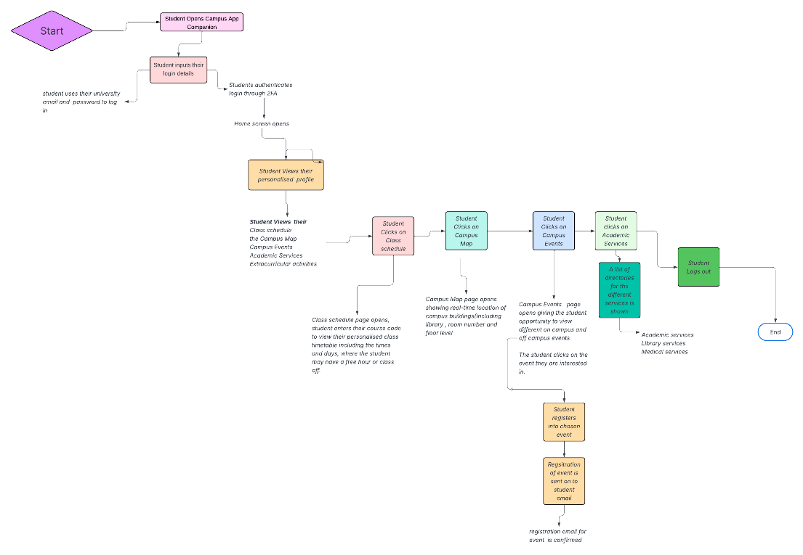

Architecture Overview
The Campus Companion app is built on a modular service-oriented architecture designed to support scalability, real time updates and seamless integration with existing university systems. The architecture prioritizes reliability, security and a simple user experience across multiple mobile platforms. The app composes four major layers. This includes the Client Layer, Application Layer, Integration Layer and Data Layer
Client Layer- This layer includes the mobile interface in which students interact with daily, the focus for this layer is the speed, accessibility and personalization. The main components include both IOS and Android Mobile apps to design and build a cross framework to ensure there is consistency and faster development cycles.
A responsive Web Portal for students who prefer desktop use.

UI Modules
- Dashboard
- Schedule and Timetable
- Campus Map and Navigation
- Events and Clubs
- Notification Centre
- Student Services Directory
- Profile and settings
2. Application Layer - This layer holds the components of the core and logic layer which empowers the app’s features. The core services include the User Profile Service, which is used to manage the student account, their preferences and personalization settings.
- Schedule & Academic service- Synching class timetables, assignment deadlines, academic updates
- Campus Navigation Services: Provides information on building data, room locations and route generation.
- Events and Club Service- Showing the different Campus events, club activities and recommendations.
- Notifications Services- Sends real-time alerts for class changes deadlines and campus updates.
- Search Service: Enable fast lookup of buildings, services, events and resources.
3. Integration Layer- This Layer connects the app to university systems and external services. The main components include the
- API Gateway- Central entry point for client requests
- Integration Connectors including- Learning Management System, Student information System, Campus Security and Emergency alerts, Library Systems and Authentication Providers (SSO, OAuth, university login )

4. Data Layer- This layer stores and manages the data for the app including
- Relational Database-This stores the data such as user profiles, schedules, events and service listings.
- No SQL Database: Handles unstructured or high-volume data like logs, analytics and cached content.
- File Storage- Stores media assets, documents and campus resources.
Data Design- ERD Table
- Student  (Representing the primary user of the app) | Attributes:  - Student ID  - Name  - University email  - Program/Major  - Year of Study  - Preferences- (notification settings, accessibility options, interests)  Relationships:  Enrolled in - Course  Attends – Events  Receives- Notification  Bookmarks-Location/Event Services
- Course (Represents academic modules students are enrolled in) | Attributes:  - Course ID  - Course Name  - Instructor  - Schedule (times, days)  - Location (building, room)  Relationships  - Has many- course sessions  - Belongs to -Student (via Enrolment)  - Linked to – Notifications (e.g., room change)
- Course Session  (Represents individual class meetings). | Attributes  - Session ID  - Date & Time  - Room  - Session (lecture, lab, tutorial)  Relationships  - Belongs to – Course  - Generates to- Notifications
- Campus Location  Representing building, rooms, facilities, and points of interest | Attributes  - Location ID  - Name  - Type  - Coordinates  - Accessibility info  Relationships  - Used by -Course Session  - Used by – Event  - Referenced by- Navigation Service
- Event- Represents campus events, club meetings, workshops and activities | Attributes  - Event ID  - Title  - Description  - Host (Club, Department)  - Date &Time  - Location  - Category (social, academic, cultural, wellbeing)  Relationships  - Attended by – Student  - Hosted at -Campus Location
- Campus Service- Represents student services and administrative Resources | Attributes  - Service ID  - Name  - Category (counselling, advising, financial aid and IT Support  Relationships  - Accessed by- Student  - Linked to- Notifications (e.g. appointment reminders)
- Notification- Represents alerts sent to students | Attributes  - Notification ID  - Type (class change, event reminders, service update)  - Timestamp  - Message Content  Relationships-  Sent to – Student  Triggered by- Course
- User- Preference  Represents personalization settings | Attributes  - Interests (clubs, topics, event categories)  - Notification preferences  - Saved Location  - Accessibility settings  Relationships- Belongs to- Student

  - Data that does not necessarily need to be collected in line with GDPR rules
To comply with GDPR principles and ethical design, the app collects only what is necessary for functionality This is to protect student’s Privacy accordding to GDPR principles and regulations The data that does not need to be collected are

- Personal tracking
- Their Health records
- Mental Health information
- Financial data
- Visa/Immigration Status
- Biometric Data

Usability and UI Design
A strong usability foundation ensures that the Campus Companion App feels predictable and supportive for all students, The following decisions guide the navigation, layout and interaction patterns

Navigation | - Bottom navigation bar with 4-5 core sections (Home, Timetable, Map, Events, Services)  - Consistent global navigation available from every screen  - Deep linking from notifications to relevant screens (e.g., room change – Map  - Search Bar  - clear page titles to maintain orientation
Layout Consistency | - UI Components (cards, lists, buttons) to create predictable patterns.  - Consistent spacing, typography and iconography across all modules  - Modular Dashboard  - Clear Visual Hierarchy
Feedback & Messaging | Real-time feedback for actions (e.g. “Event saved”, Location added to favourites)  Non-intrusive notifications for time-sensitive  Error messages written in plain language with actionable steps  Loading states to reduce wait time  Confirmation Prompts

Accessibility
Heading & Structure | - Logical heading hierarchy (H1, H2,H3)  - Landmarks for navigation (header, main, footer)  - Clear section labels for screen readers.
Labels & Instructions | - Descriptive Labels  - Form fields  - Icons
Keyboard Navigation & Focus | - Full keyboard operability for interactive elements  - Visible focus states with high-contrast outlines.  - Logical tab order that matches visual layout  - No keyboard traps
Contrast & Visual Clarity | - Text and UI elements meet the 4:51 contrast ratio  - Avoid reliance on colour  - Adjustable Text Size

Privacy, Security and Compliance
The Campus Companion App follows GDPR principles and university data governance standard.
On a Lawful Basis, the app follows the principles in the aspect of Contractual necessity: This means that providing schedules, navigations and notifications are a requirement for Student Services. As well as that Consent is another required aspect as an optional feature to create personalized recommendations and location-based navigation.
On the data Minimisation aspect, the app only needs to collect data that is relevant to students, this excludes, their health data, their location tracking and financial or biometric information.

On a Security Measure basis, it is Important that
- Data is encrypted and at rest, this means that it is not required to collect any data that is not required for the app.
- Regular penetration testing and vulnerability scanning is in place
- Secure authentication is through the university SSO
- And there is a strict API access Control and rate limiting

Deployment Plan
A highly-level deployment strategy ensures that reliability, scalability and smooth updates runs throughout the app.
One of the deployment plans was to host the mobile app through infrastructure. This includes
- Cloud-hosted environment using containerised services
- Auto-scaling groups to handle peak periods (e.g. Start of Semester)
- Load Balancers for distributing traffic across services.
Another deployment is the CI/CD Pipeline, this includes
- Automated testing
- Staged Deployment
- Canary releases for new features to reduce risk
Another deployment is the Pre- Launch Testing which includes
- Usability testing with diverse student groups
- Accessibility audits
- Performance testing for high-load scenarios
- Security penetration testing.
Another deployment is the App Distribution this where the app is distributed and published to the IOS APP Store and Google Play Store and it is university managed.

The Last Deployment stage is the Monitoring & Maintenance, this includes
- Real-time monitoring
- Analytical dashboards
- Regular Updates
- Incident response plan with clear escalation paths.

Wireframe
